Project Design Phase-II
Data Flow Diagram & User Stories

Date | 3 October 2026
Team ID | 6ab63952414835f68f9990bf9
Project Name | Streamlining IT Procurement: Automating Standard Laptop Orders with Flow Designer
Maximum Marks | 4 Marks

Data Flow Diagrams:
A Data Flow Diagram (DFD) is a traditional visual representation of the information flows within a system. A neat and clear DFD can depict the right amount of the system requirement graphically. It shows how data enters and leaves the system, what changes the information, and where data is stored.
Example: DFD Level 0 (Industry Standard)
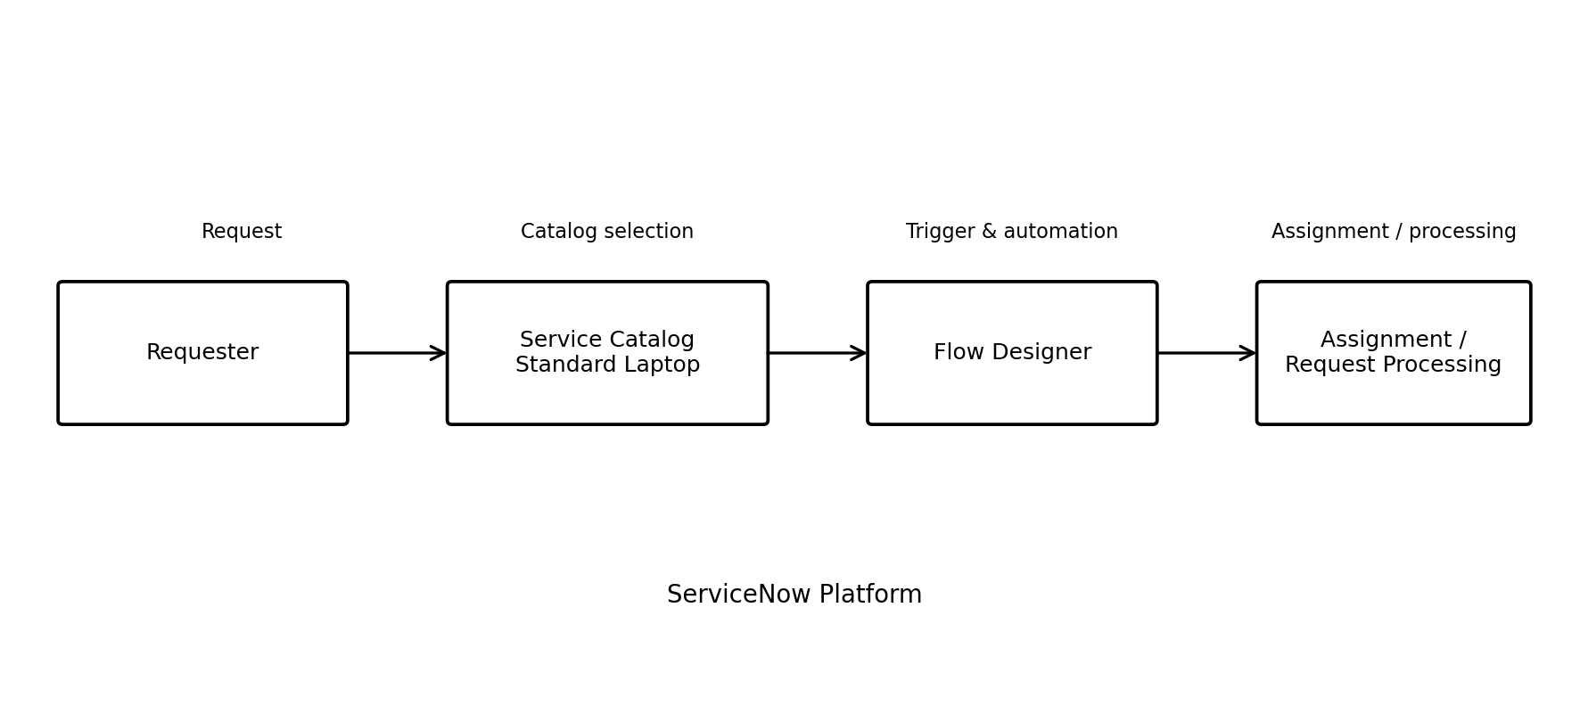
Example: (Simplified)



User Stories
Use the below template to list all the user stories for the product.
User Type | Functional Requirement (Epic) | User Story Number | User Story / Task | Acceptance criteria | Priority | Release
Requester | Laptop Request | USN-1 | As a requester, I can select the Standard Laptop catalog item and submit a request. | A Standard Laptop request is submitted through Service Catalog. | High | Release-1
ServiceNow Platform | Request Capture | USN-2 | As the system, I can capture the submitted Standard Laptop request for processing. | The submitted request is available for the workflow. | High | Release-1
Flow Designer | Automation Trigger | USN-3 | As the system, I can trigger the defined Flow Designer workflow when the Standard Laptop request is submitted. | The flow starts for the submitted request. | High | Release-1
Flow Designer | Automated Assignment | USN-4 | As the system, I can perform the required assignment step for the Standard Laptop request. | The request is assigned as defined by the workflow. | High | Release-1
ServiceNow User | Request Processing | USN-5 | As a ServiceNow user, I can process the Standard Laptop request through the automated workflow. | The request follows the configured process and can be completed. | Medium | Release-1

